**DEPARTMENT PART**

**Estate Officer**

“**Application Receipt by Estate Officer cum Joint Secretary**”

**Step 1:**

At first login to Service plus web portal**: (**<https://tathyasathi.bangla.gov.in/>).

Login as “**Estate Officer**” in Service plus web portal.

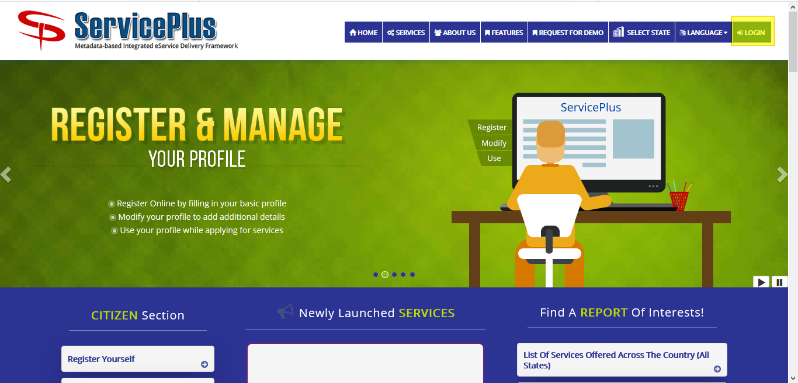

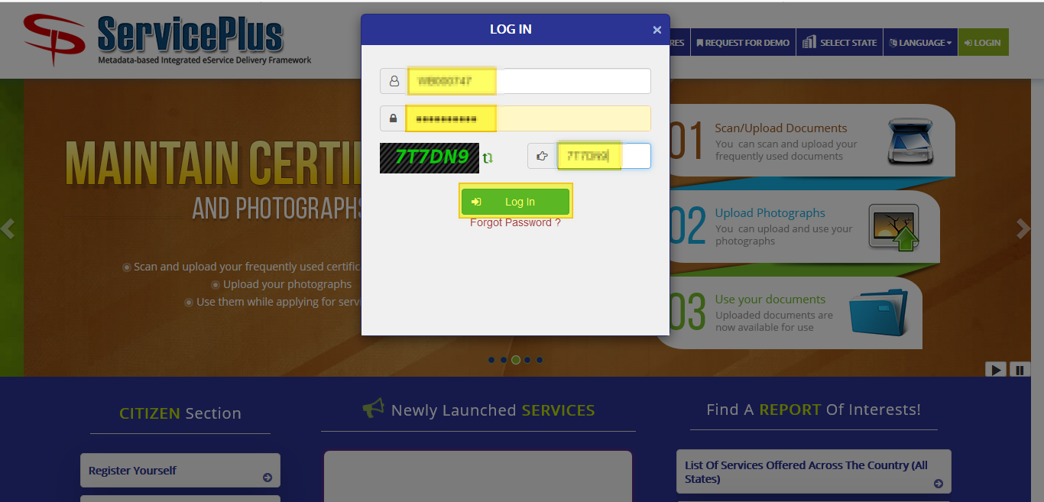

**Step 2:**

Now Go to **“Message Box”** and select **“Inbox”**.

In Inbox select the service **“Application for License Renewal of Flat in Bidhannagar Municipal Corporation Area”** and select the task **“Application Receipt by Estate Officer cum Joint Secretary”** and select **“Get Data”.**

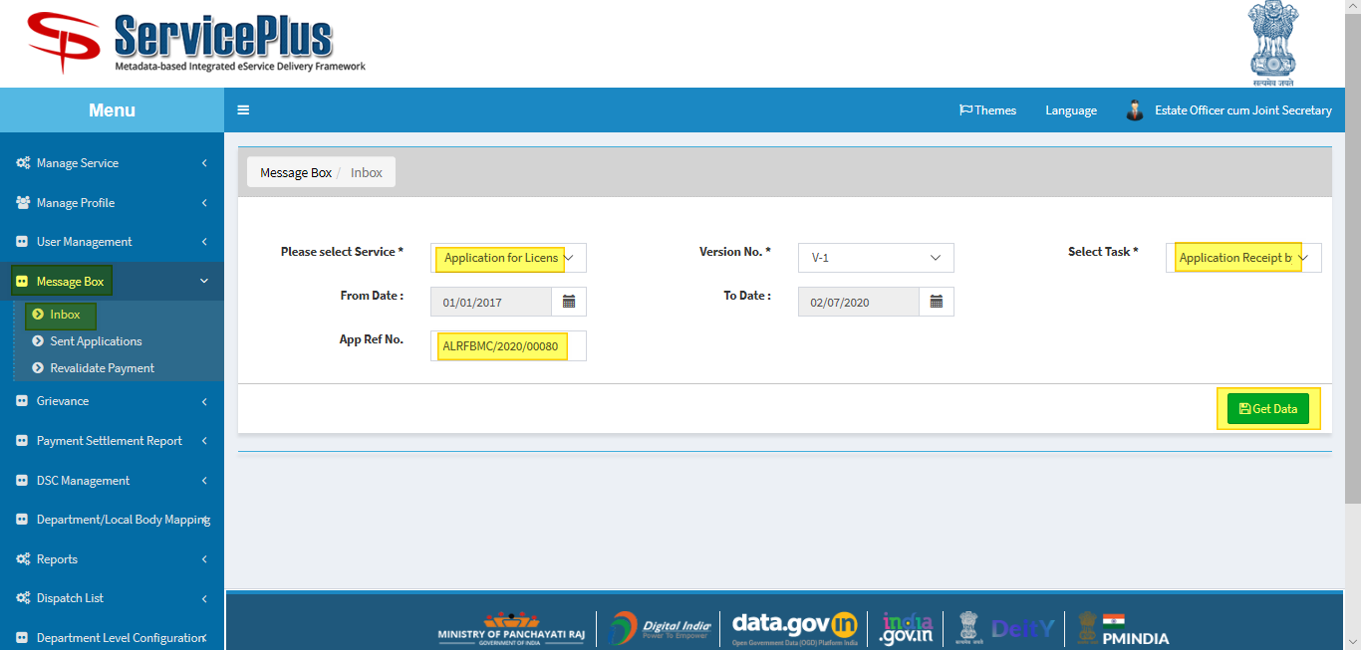

**Step 3:**

Select **“Pull”/ “Take Action”** to take action.

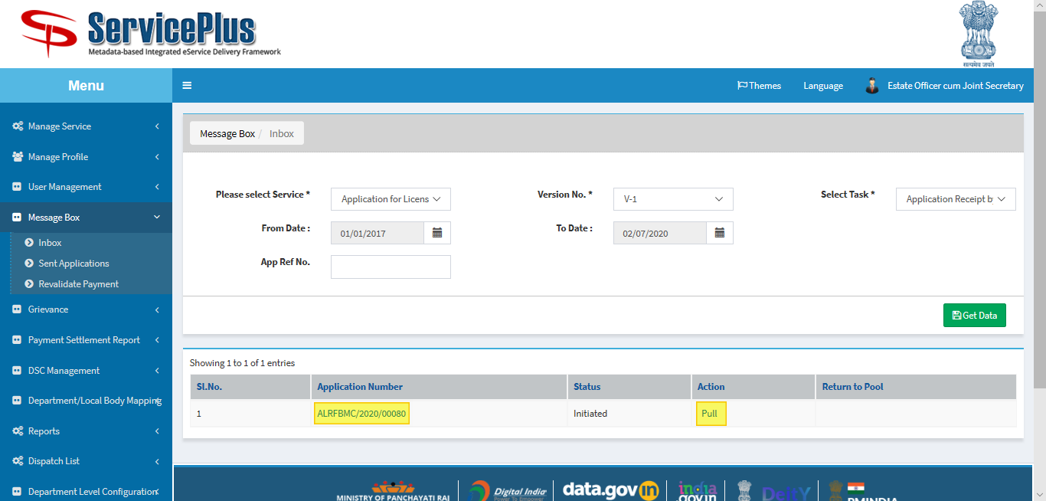

**Step 4:**

Select **“View Processing History”** to see the history of the application.

Action of the form can be taken by **Estate Officer** by taking action in two steps to **forward** and **Forward To-Supervisory Head Clerk** for Verification to “**Head Clerk”** and Give remarks and submit.

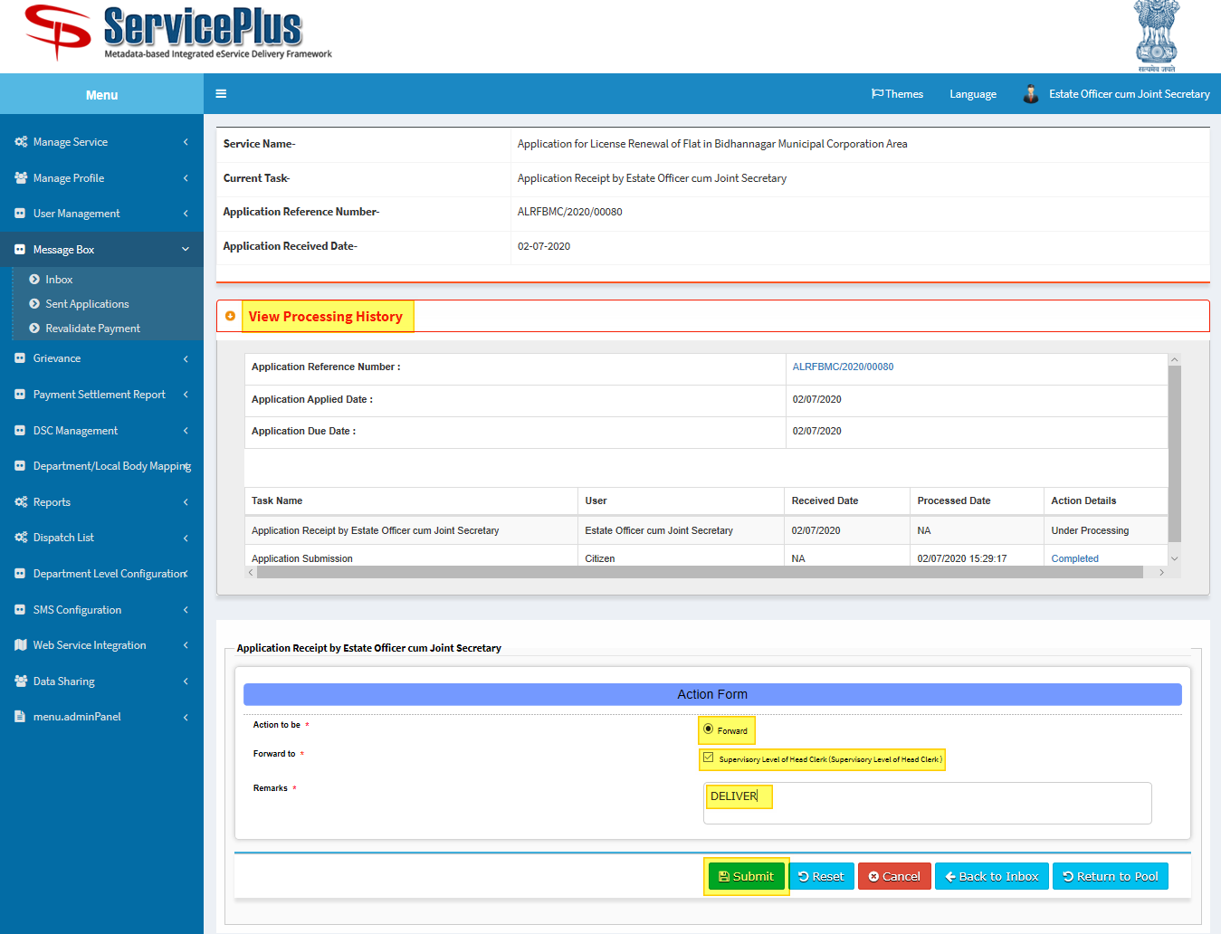

**Step 5:**

After Submit.

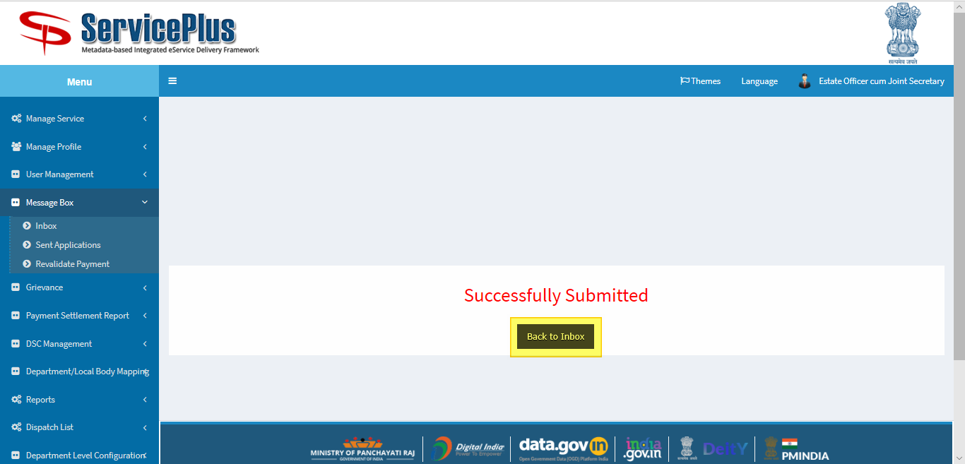

**Head Clerk**

“**Verification Application and Preparation License by Head Clerk”**

**Step 6:**

At first login to Service plus web portal**: (**<https://tathyasathi.bangla.gov.in/>) to apply for the **Application for License Renewal of Flat in Bidhannagar Municipal Corporation Area**

Login as “**Head Clerk**” in Service plus web portal.





**Step 7:**

Now Go to **“Message Box”** and select **“Inbox”**.

In Inbox select the service **“Application for License Renewal of Flat in Bidhannagar Municipal Corporation Area”** and select the task **“Verification Application and License Preparation by Head Clerk”** and select **“Get Data”.**

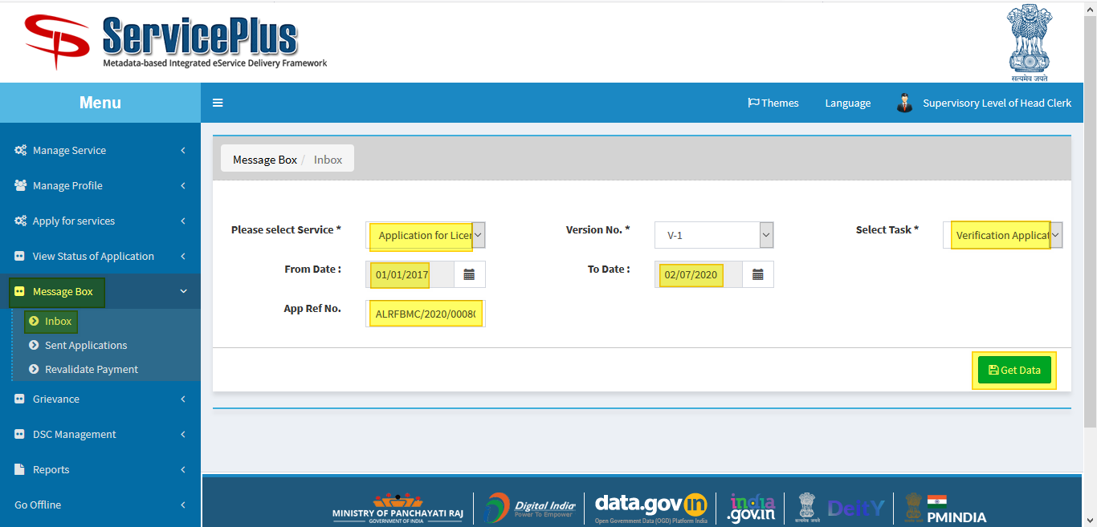

**Step 8:**

Select **“Pull”/ “Take Action”** to take action.

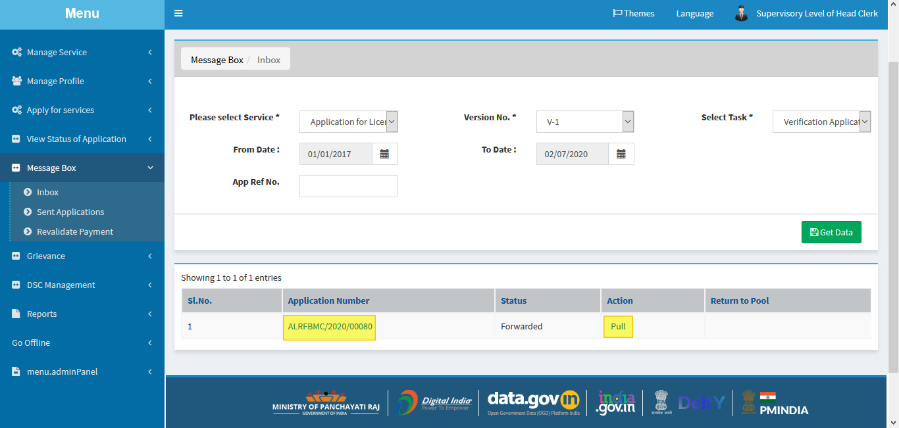

**Step 9:**

Select **“View Processing History”** to see the history of the application.

Action of the form can be taken by **Estate Officer** by taking action in three steps to **forward to**

* **Application Submission Shortfall**
* **Issuance License by Estate Officer cum Joint Secretary**.
* **Recommendation for Rejection**

If selected “**Issuance License by Estate Officer cum Joint Secretary**” then the new license section should be filled up and submit button clicked.

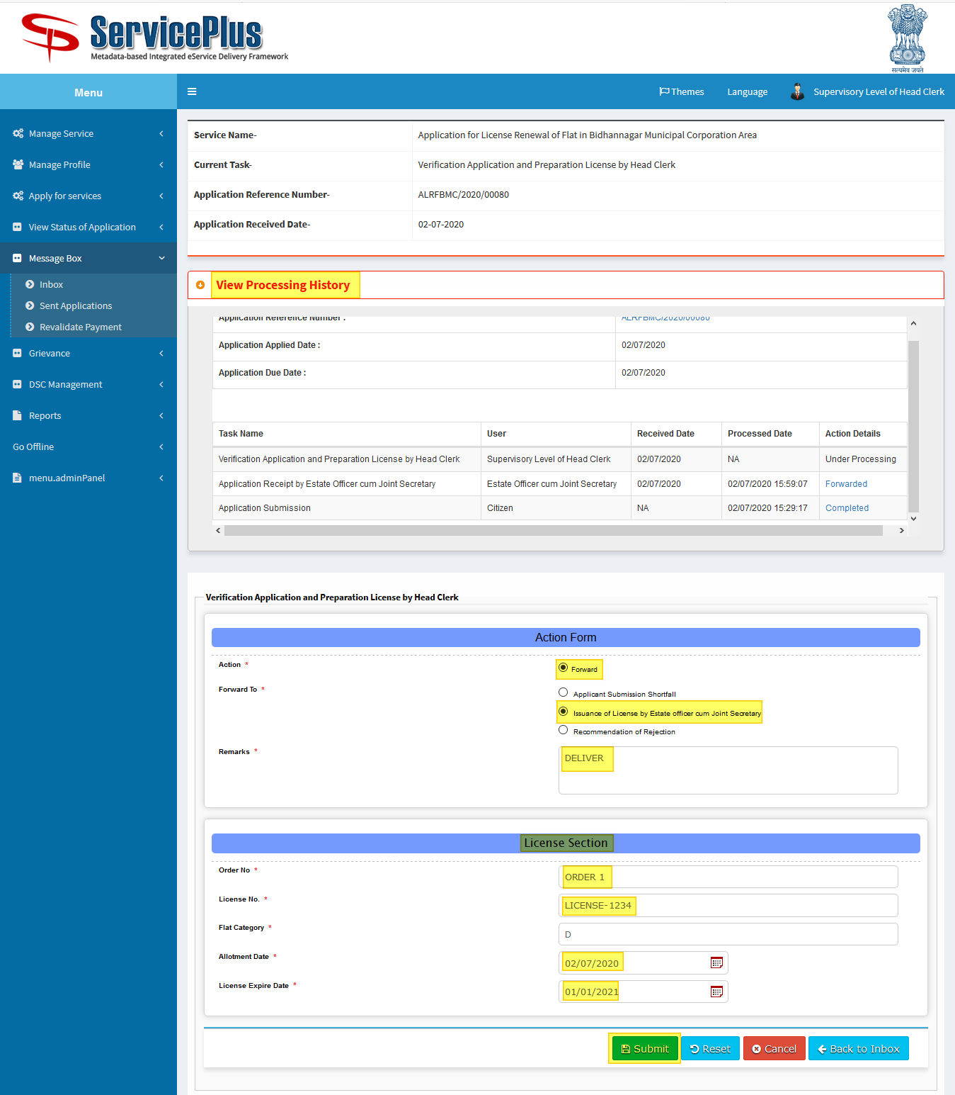

**Step 10:**

Now download the document by clicking the file icon.

And submit it.

An example certificate is attached.

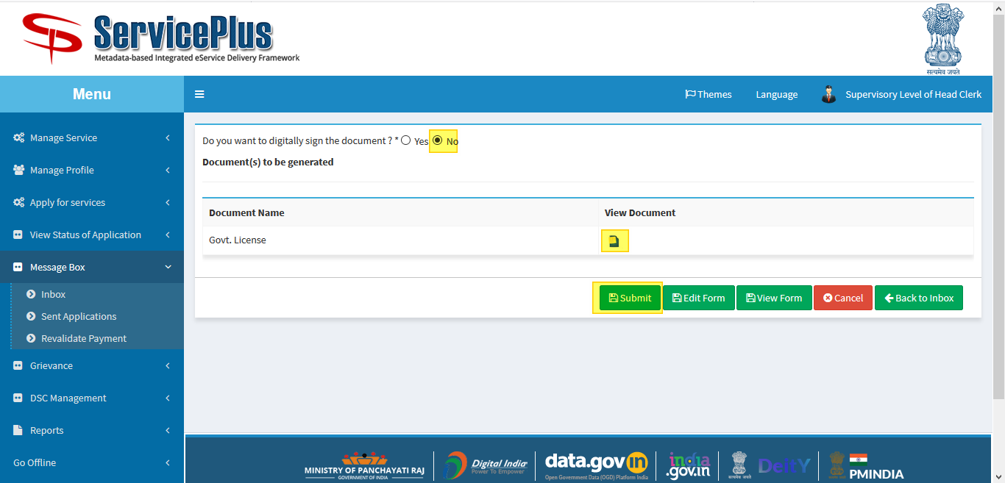

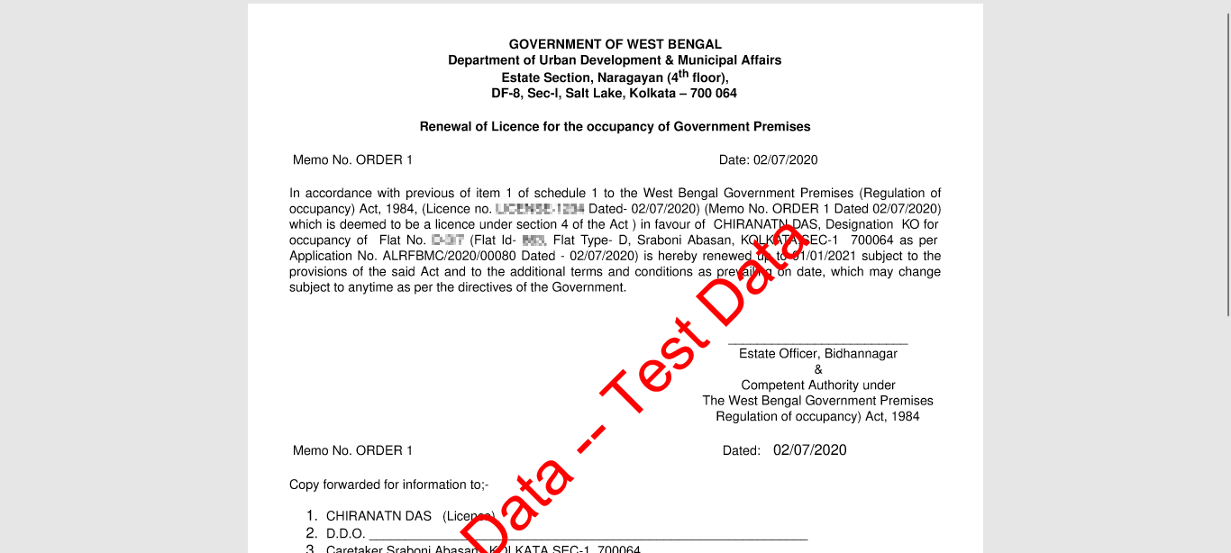

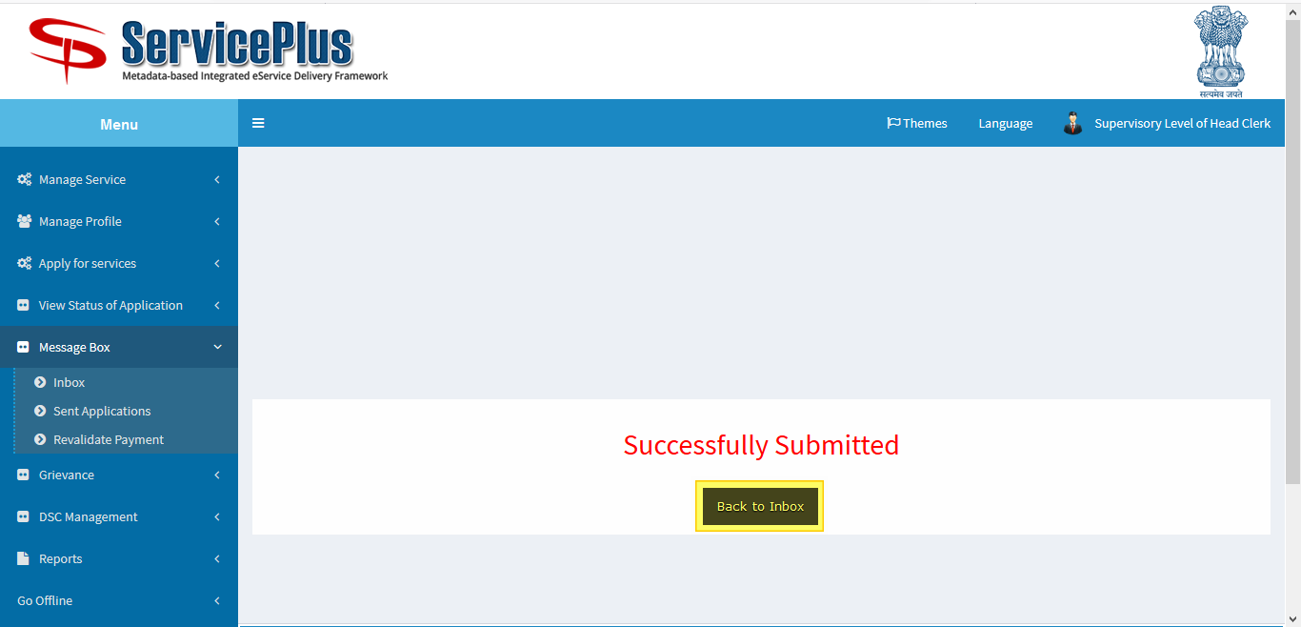

**Estate Officer**

**“Issuance of License by Estate officer cum Joint Secretary”**

**Step 11:**

Again Login as **“Estate Officer**” in Service plus web portal.





**Step 12:**

Select the service **“Application for License Renewal of Flat in Bidhannagar Municipal Corporation Area”** and select the task **“Issuance of License by Estate Officer”** and select **“Get Data”.**

Select **“Pull” / “Take Action”**.

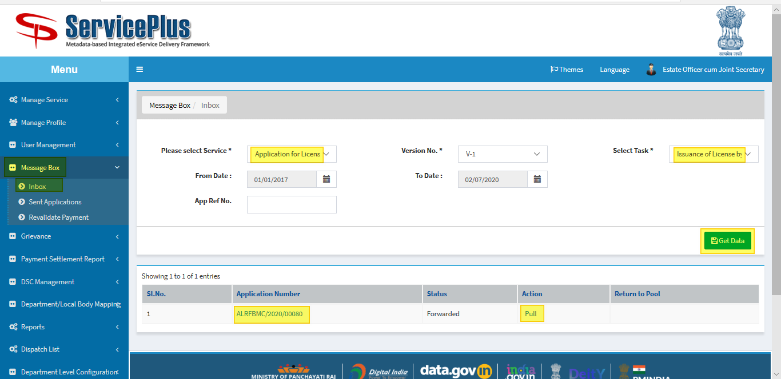

**Step 13:**

Select **“View Processing History”** to see the history of the application.

Action of the form can be taken by **Estate Officer** by taking action to **Deliver, Reject or Recommended**.

By selecting “**Deliver**”.

* **“Generate License for Government/Non-Government Employee**” button is to hit to enable the submit button and **generate the license.**

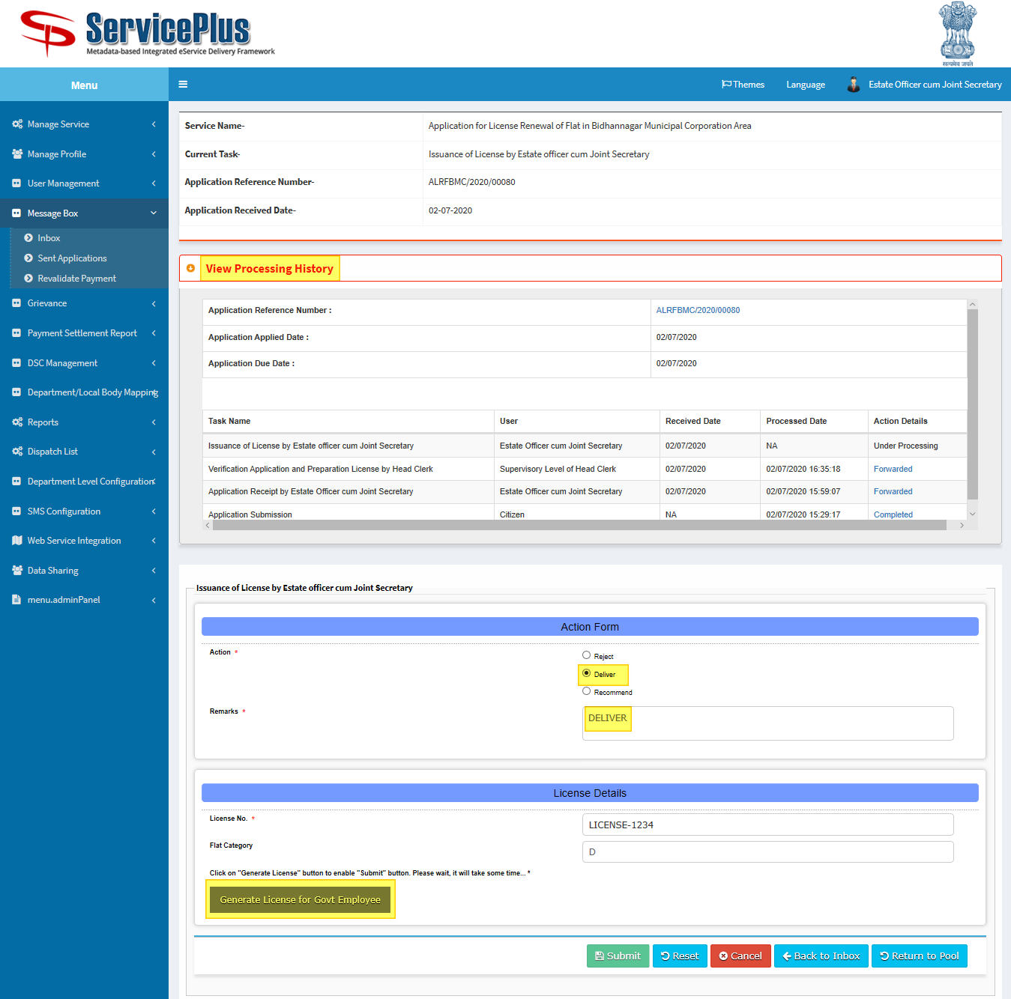

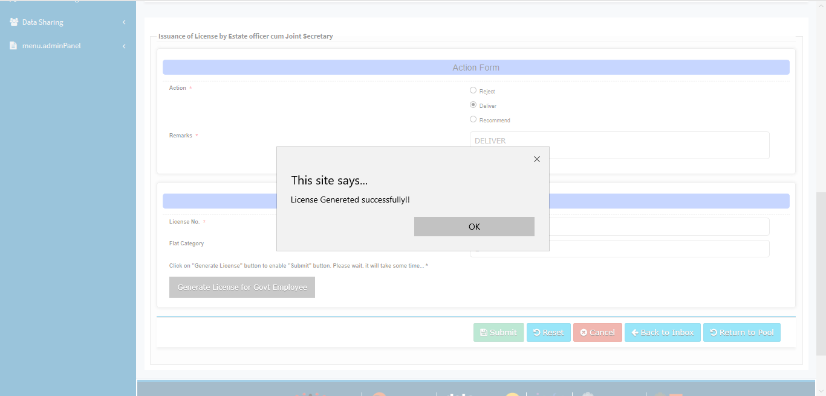

**Step 14:**

Submit button is enabled.

Submit it to deliver.

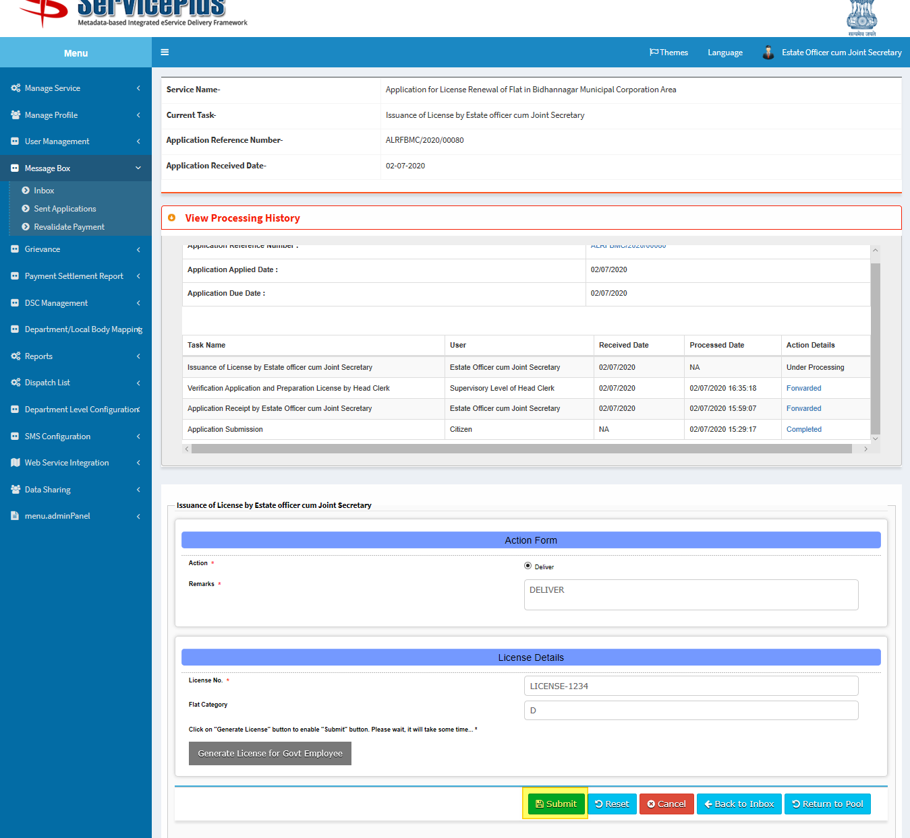

**Step 15:**

Here upload the file by clicking the **browse** button and **submit**.

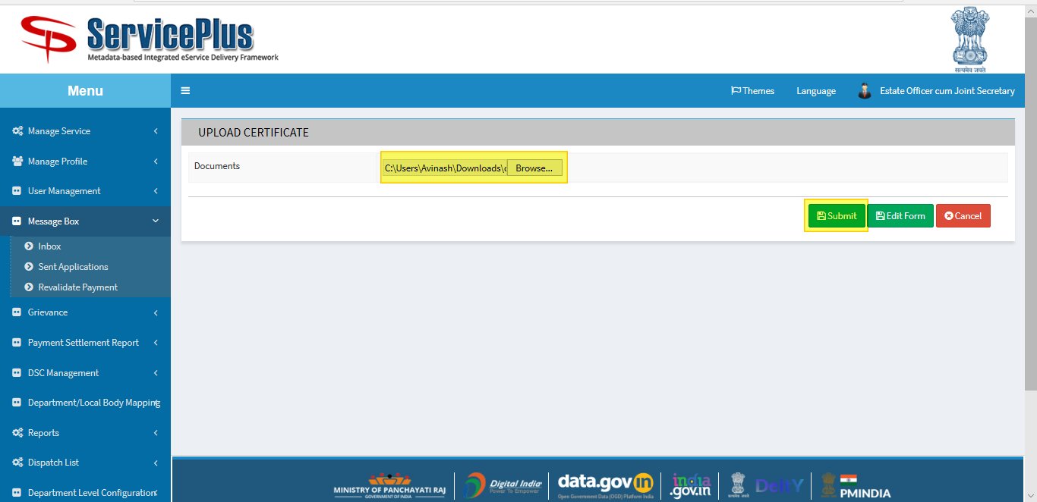

**Step 16:**

Here again download file by clicking the **file** icon and **submit**.

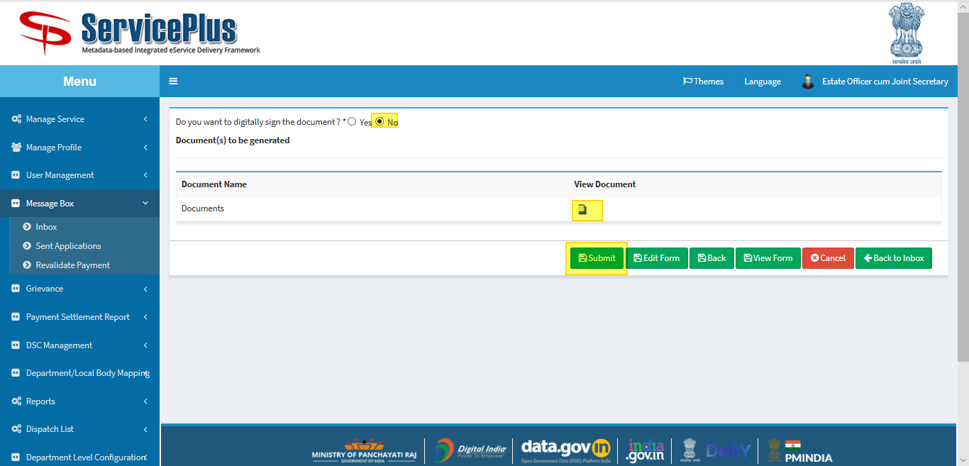

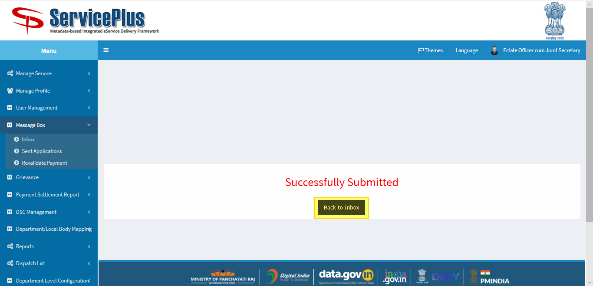

**SHORTFALL SELECTED**

**Head Clerk**

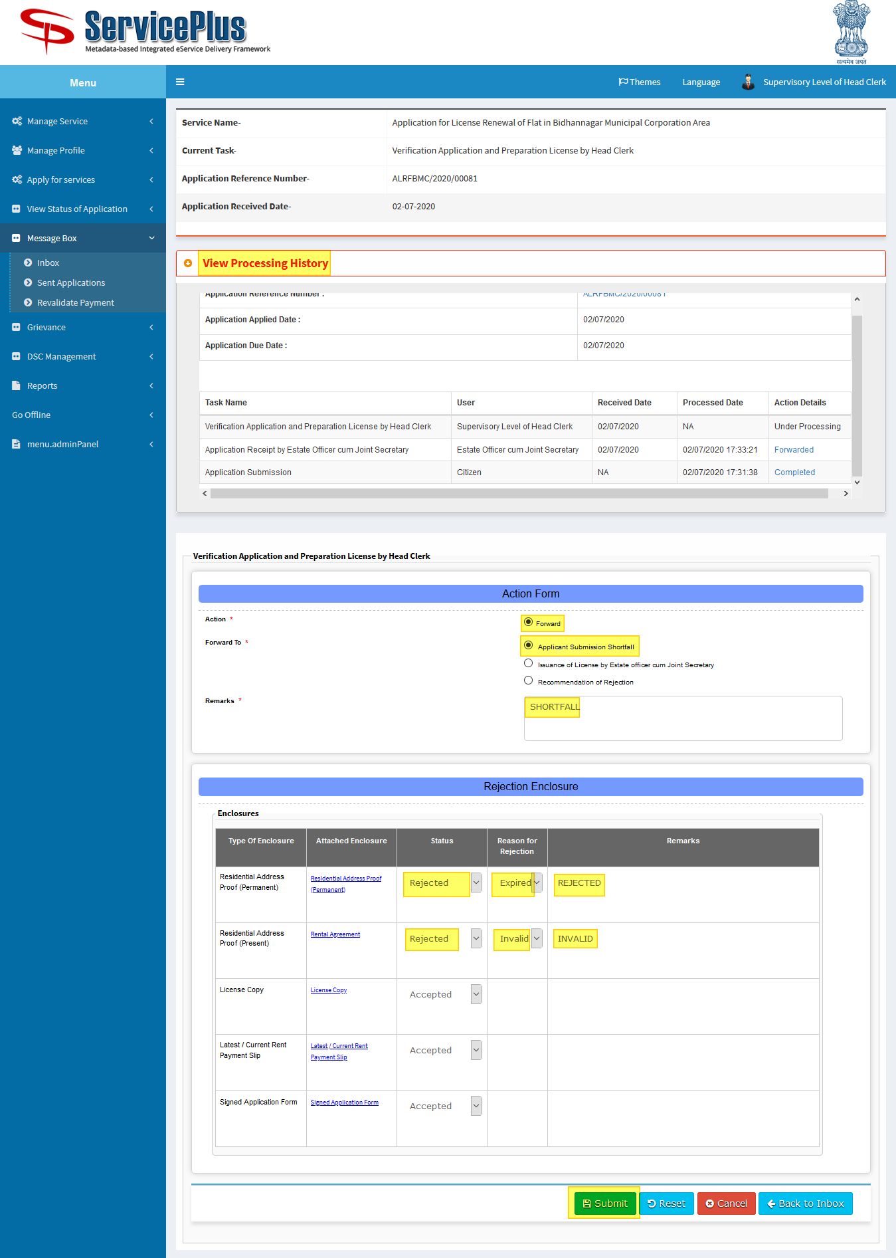

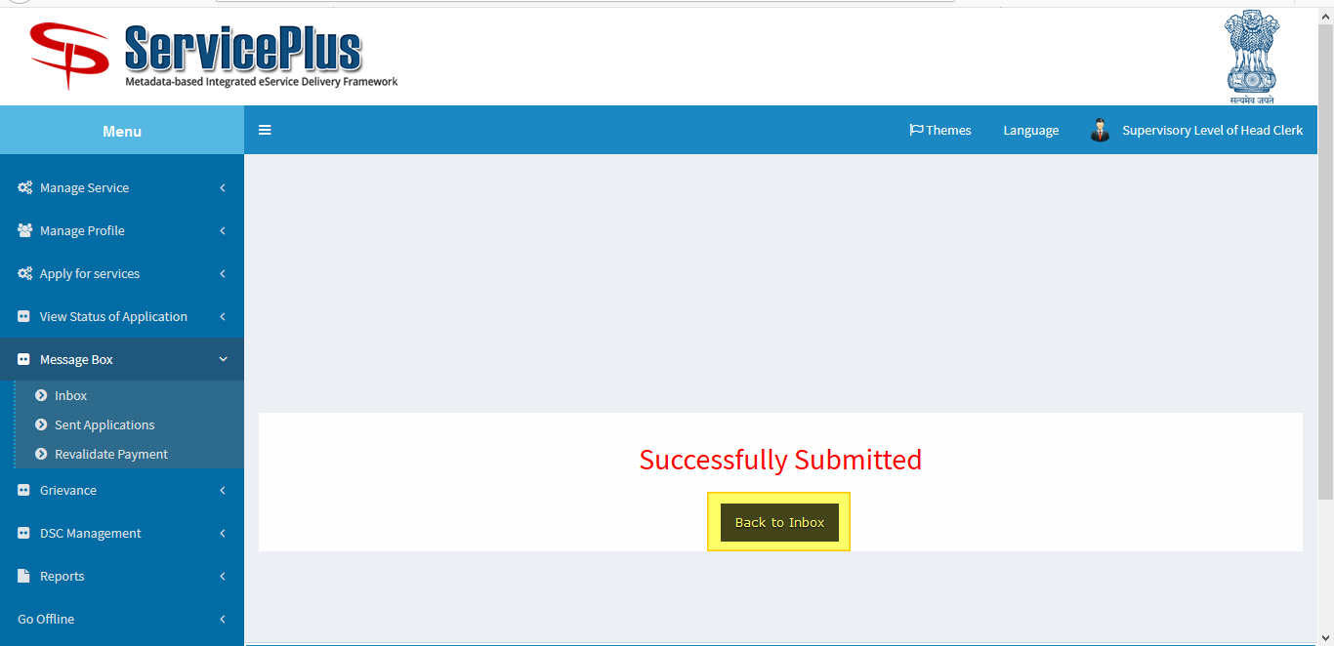

**RECOMMENDATION FOR REJECTION**

**Head Clerk**

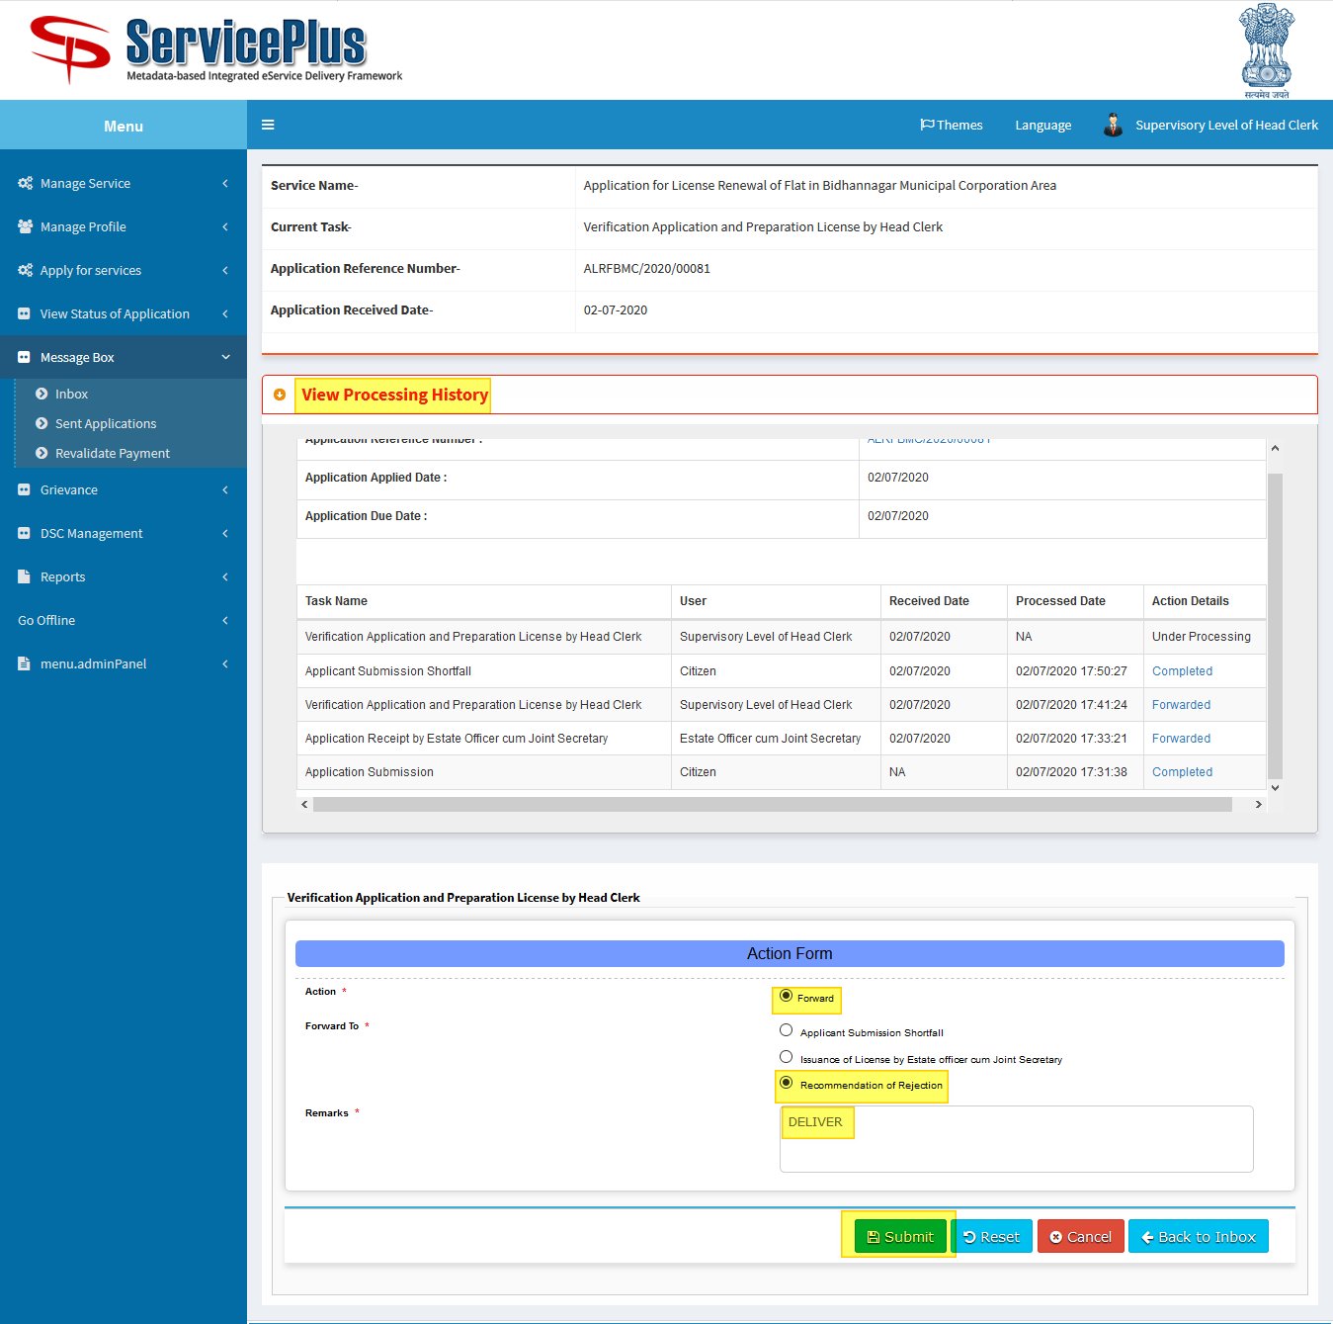

**RECOMMENDATION FOR REJECTION**

**Estate Officer**

**Step 1:**

Again Login as “**Estate Officer**” in Service plus web portal.



**Step 2:**

Now Go to **“Message Box”** and select **“Inbox”**.

In Inbox select the service **“Application for License Renewal of Flat in Bidhannagar Municipal Corporation Area”** and select the task **“Recommendation of Rejection”** and select **“Get Data”.**

Select **Pull/Take Action.**

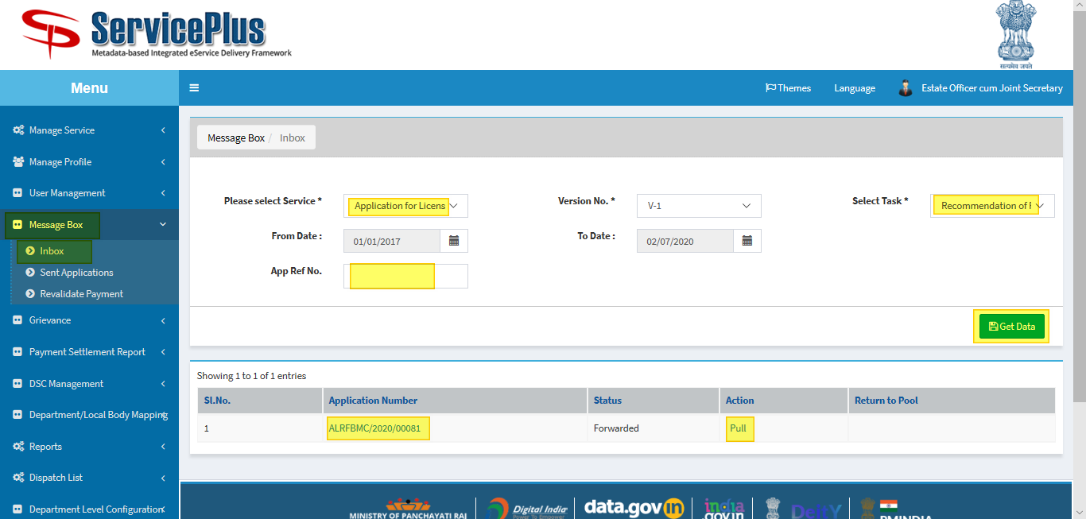

**Step 3:**

Select **“View Processing History”** to see the history of the application.

Here **Estate Officer** Takes action by selecting **Reject** and giving **remarks** and submit.

